* Alameda County DA **Danny Lau,** DA Inspector **George Phillips,** and CDI Detective John Lee- Undercover Auto Body Shops Part Two: Operations Planning, Legal Issues and Defenses One Year Later!

**We expect participants to earn Continuing Professional Education (CPE) pursuant to CCR Section 2698.39(c)(3)**

* Alameda County District Attorneys **Jill Nerone** and **Barbara Foo:** Auto Fraud 101—the Basics and Beyond!
* A panel discussion: CDI Auto Fraud Team Sergeant **Fernando Cubangbang** and successful SIUs discuss investigative strategies and the latest fraud schemes
* Alameda County DA Inspector **Jeff Israel :** The Perfect FD1
* Mike McKee, Senior Special Agent, NICB: Trending fraud: unscrupulous tow and body shops, pedestrian staged accidents, and more!

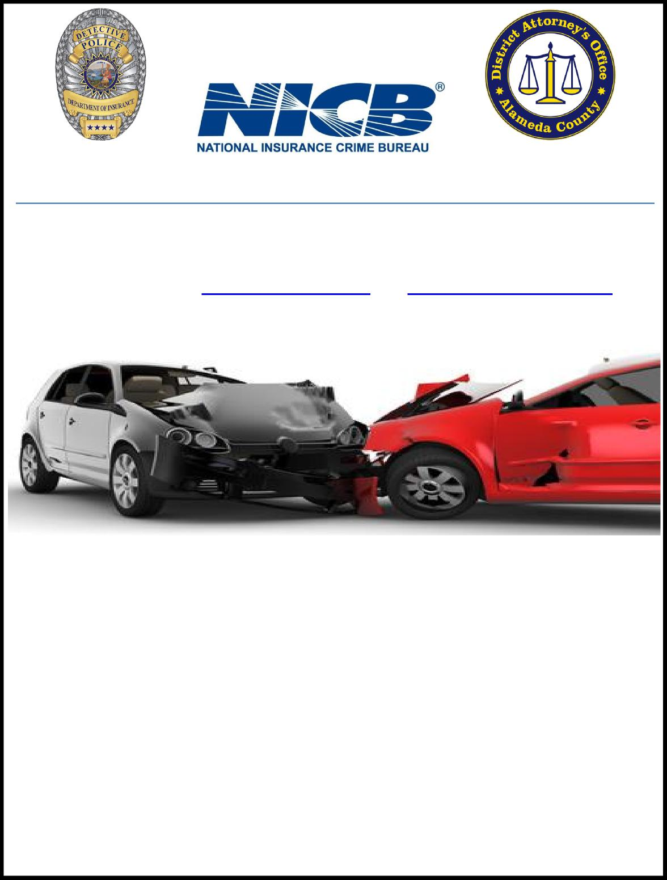

AUTO INSURANCE FRAUD TRAINING SEMINAR

*May 30, 2019, 9:00 a.m. – approx. 4:00 p.m.*

(Registration opens at 8:30 a.m.)

To register, e-mail [lisa.basler@acgov.org](mailto:lisa.basler@acgov.org) and [kathleen.dadci@acgov.org](mailto:kathleen.dadci@acgov.org)

*SHANNON COMMUNITY CENTER*

*11600 SHANNON AVENUE, DUBLIN, CA*

The Alameda County District Attorney’s Office, and the California Department of Insurance, Golden Gate Region, in partnership with NICB, cordially invite you to attend an auto insurance fraud seminar focusing on the investigation and prosecution of auto insurance fraud. Topics will include:

* Opening remarks by the Alameda County District Attorney’s Office and Deputy Insurance Commissioner **George Mueller** and Alameda County District Attorney **Nancy E. O’Malley**